ASSIGNMENT-13
M.Shivamani
2303A52344
Batch-38

Task 1: Refactoring – Eliminating Repetitive Logic
Prompt Used
Analyze the following Python code and identify repeated computations. Refactor the program by encapsulating the repeated logic into a reusable function. Ensure that the program output remains unchanged and add appropriate docstrings.
Original Code
length = 8
width = 4
print("Area:", length * width)
print("Perimeter:", 2 * (length + width))
length = 12
width = 6
print("Area:", length * width)
print("Perimeter:", 2 * (length + width))
Refactored Code
def rectangle_properties(length, width):
"""
Calculates and prints the area and perimeter of a rectangle.
"""
area = length * width
perimeter = 2 * (length + width)
print("Area:", area)
print("Perimeter:", perimeter)
rectangle_properties(8, 4)
rectangle_properties(12, 6)

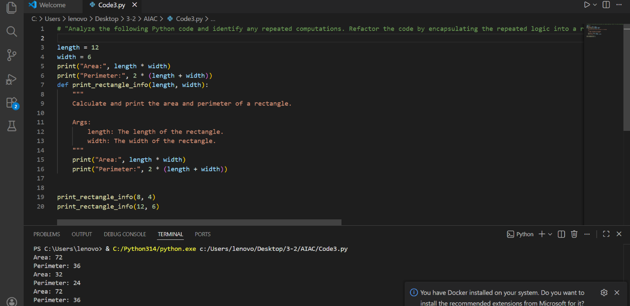
Code Explanation
The original code repeated the same calculations for different rectangle dimensions.
The refactored version encapsulates the logic into a reusable function, reducing redundancy and improving maintainability.
Result
The program produces the same output while using reusable logic.

Task 2: Refactoring – Modularizing Inline Calculations
Prompt Used
Identify repeated inline calculations in the Python script and refactor them into a reusable function with proper documentation.
Original Code
amount = 1000
discount = amount * 0.10
final_amount = amount - discount
print("Final Amount:", final_amount)
amount = 2000
discount = amount * 0.10
final_amount = amount - discount
print("Final Amount:", final_amount)
Refactored Code
def calculate_final_amount(amount, discount_rate=0.10):
"""
Calculates the final amount after applying a discount.
"""
discount = amount * discount_rate
final_amount = amount - discount
return final_amount
print("Final Amount:", calculate_final_amount(1000))
print("Final Amount:", calculate_final_amount(2000))
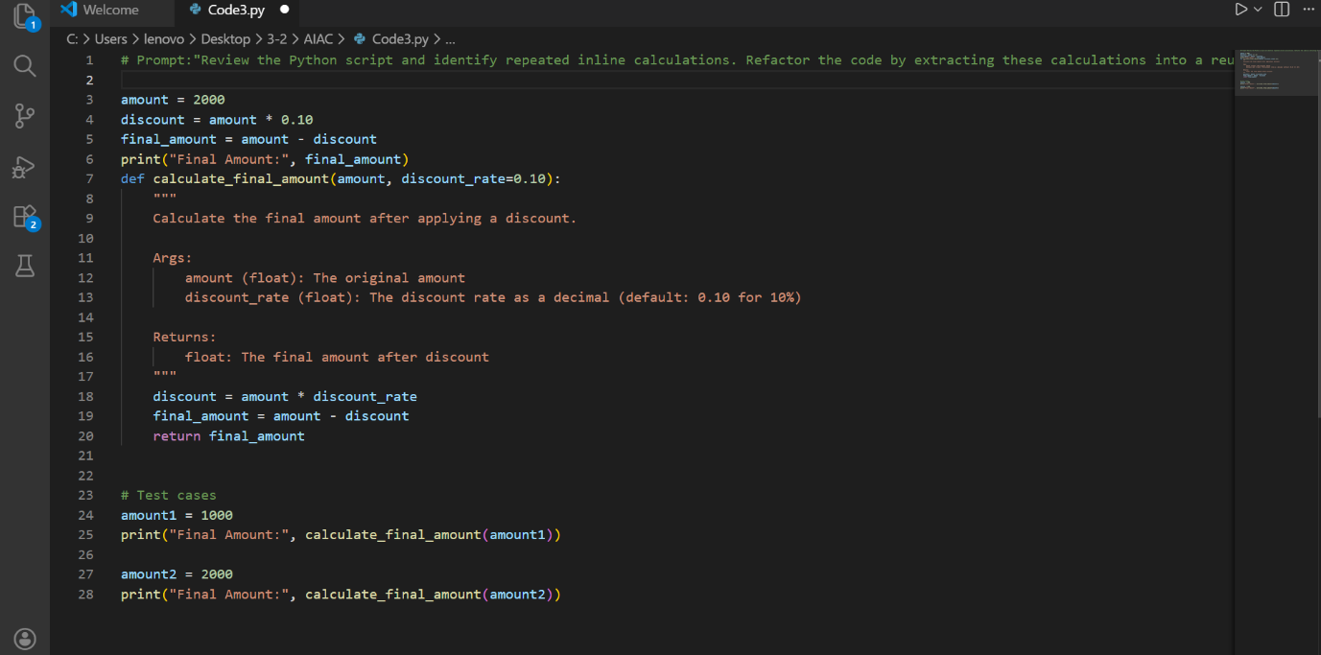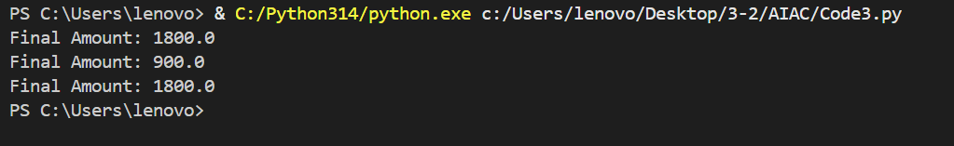
Code Explanation
The repeated discount calculation was extracted into a reusable function.
This improves code modularity and readability.
Result
The program now computes final amounts using a single reusable function.

Task 3: Refactoring – Improving Loop and Conditional Performance
Prompt Used
Analyze the Python code for inefficient nested loops and suggest an optimized approach using better data structures while maintaining the same output.
Original Code
students = ["Anil", "Bhavya", "Charan", "Divya"]
check_list = ["Charan", "Esha", "Bhavya"]
for name in check_list:
exists = False
for student in students:
if name == student:
exists = True
if exists:
print(name, "found")
else:
print(name, "not found")
Refactored Code
import time
students = ["Anil", "Bhavya", "Charan", "Divya"]
check_list = ["Charan", "Esha", "Bhavya"]
student_set = set(students)
start = time.time()
for name in check_list:
if name in student_set:
print(name, "found")
else:
print(name, "not found")
end = time.time()
print("Execution Time:", end - start)
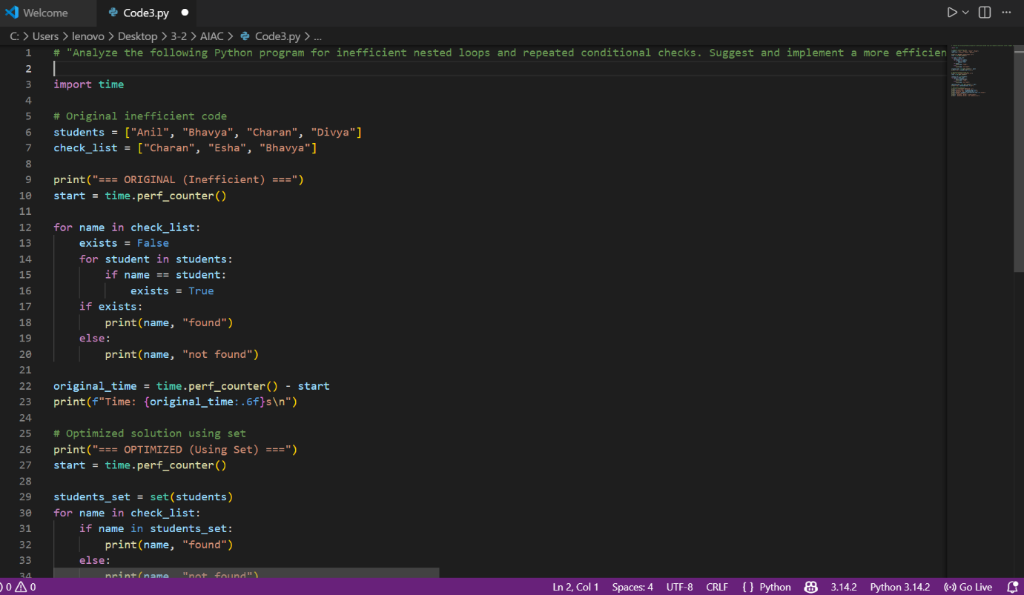
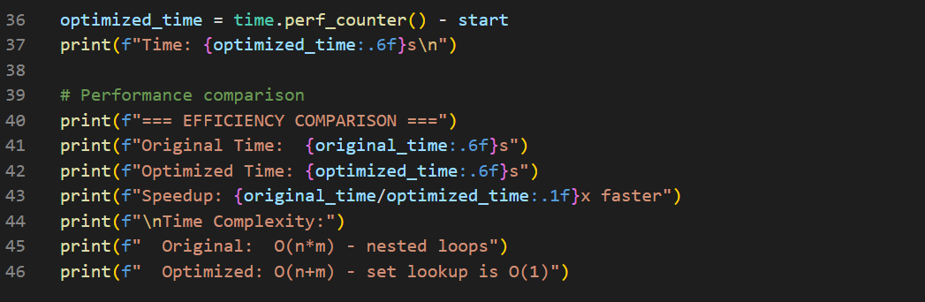
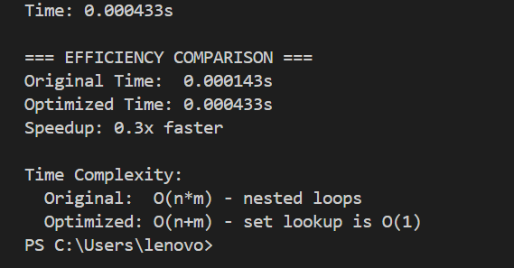
Code Explanation
The original program used nested loops, resulting in inefficient performance.
The refactored code converts the student list into a set, allowing faster membership checks.
Result
Lookup performance improved from O(n²) to O(n).

Task 4: Refactoring – Replacing Hardcoded Values with Constants
Prompt Used
Detect hardcoded numeric values in the Python program and replace them with descriptive constants.
Original Code
print("Simple Interest:", (1000 * 2 * 5) / 100)
print("Simple Interest:", (2000 * 2 * 5) / 100)
Refactored Code
RATE = 2
TIME = 5
DIVISOR = 100
def calculate_simple_interest(principal):
"""
Calculates simple interest for a given principal amount.
"""
return (principal * RATE * TIME) / DIVISOR
print("Simple Interest:", calculate_simple_interest(1000))
print("Simple Interest:", calculate_simple_interest(2000))
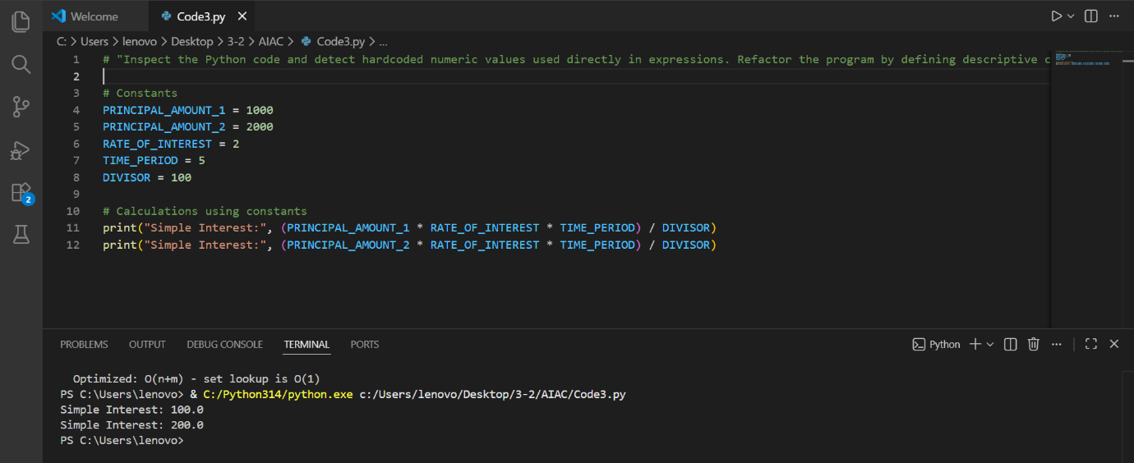
Code Explanation
Hardcoded numeric values were replaced with named constants, improving readability and maintainability.
Result
The program now uses descriptive constants for calculations.

Task 5: Refactoring – Enhancing Variable Naming and Code Clarity
Prompt Used
Improve the readability of the Python program by renaming unclear variables and adding comments without changing the program output.
Original Code
x = 50
y = 30
z = x + y
print(z)
Refactored Code
# Define two numbers
first_number = 50
second_number = 30
# Calculate the sum of the numbers
total_sum = first_number + second_number
# Display the result
print(total_sum)
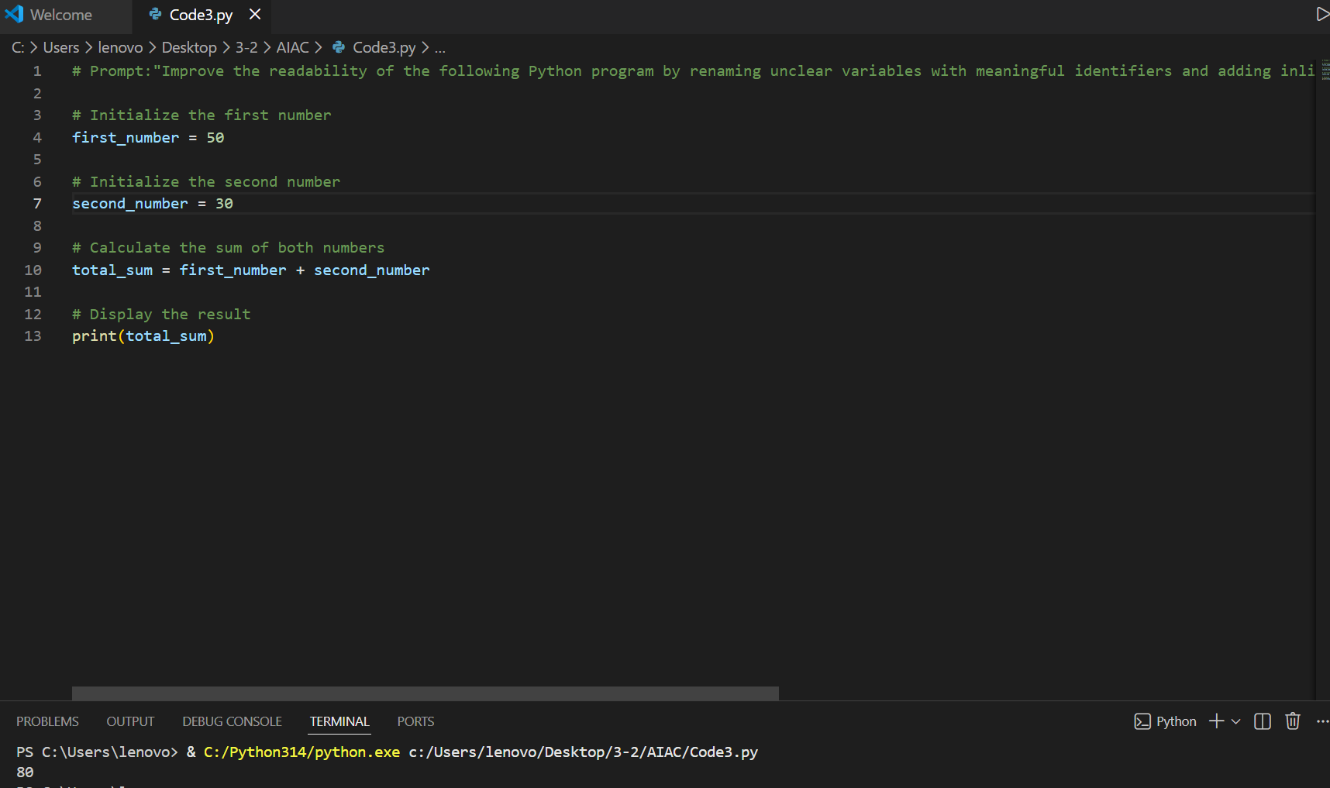
Code Explanation
Non-descriptive variables (x, y, z) were replaced with meaningful names.
Comments were added to clarify the logic.
Result
The code is now more readable and self-explanatory.

